

BluePages Tool User Guide

V1.0 Beta



Li Mingjie

February 18, 2011
Ownership
Owner | Li Mingjie (Martin)
Email | mingjieli@cn.ibm.com  limingjie0791@gmail.com (Personal Email)
Issue Date | February 18, 2011

Reviewer
Reviewer | Du Yan Ping (ypdu@cn.ibm.com)

Changes
Feb 18, 2011 | Draft

Copyright © IBM Corporation 2010, 2011 Li Mingjie
About This Guide
This guide will walk you through functions of BluePages Tool. For development guide, please contact me via Email.

Audience
Targeting all IBMers who use BluePages.
Index

Chapter 1. Introduction 4
Try it out now! 4

Chapter 2. Prerequisites 5
Operating System 5
Network 5

Chapter 3. Keyboard Shortcuts 6
Keyboard Shortcuts 6

Chapter 4. Functions 7
Batch Search 7
Organize Columns 9
Export 10
Copy 11
Email 12
Go to BluePages 12

Introduction
This tool is designed to save our precious time on BluePages, especially when facing some messy mixed information. It can automatically identify Search Type for each search entry, and format search results in a spreadsheet which can later be exported into files. Several useful functions are also coming with the tool.

Try it out now!
Let’s make life easier immediately! Go through this guide to master it in less than 5 minutes.

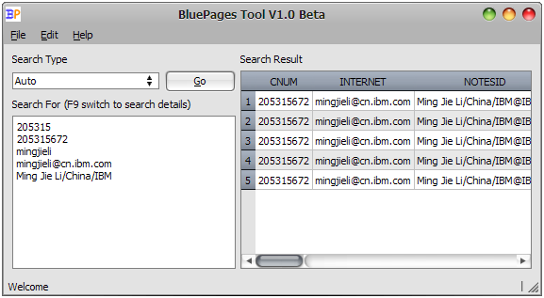
Figure 1.1 Try it out now!

Prerequisites
This tool only works under following prerequisites.

Operating System
This tool is programmed in Standard C++ and using QT framework. Theoretically, it can work under any OS that QT supports, please contact me to obtain source code if you can help compile and test it under other OS, appreciate!

Current Supported Operating System
- Windows XP or Above

Network
- IBM Intranet.
- BluePages HTTP APIs available. (http://bluepages.ibm.com/BpHttpApisv3/index.html)

Keyboard Shortcuts
Computer geeks prefer Keyboard!

Function Shortcuts
To quickly access functions.

[Ctrl][Enter] | Go!
[Ctrl][A] | Select all cells in the search result.
[Ctrl][C] | Copy selected cells to clipboard.
[Ctrl][E] | Export search result.
[Ctrl][M] | Mail all recipients.
[Ctrl][O] | Arrange columns.
[Ctrl][P] | Go to BluePages.
[Ctrl][Q] | Exit the application.
[F9] | Switch between search views.
Table 3.1 Keyboard Shortcuts

Functions
This chapter walks through all functions of the tool.

Batch Search

Choose Search Type
Leave it as Auto if no special requirement, under this criterion, BluePages tool is designed to automatically check each search entry to identify whether it is CNUM, S/N, Notes ID, Internet Address, or Name.

Tip - Auto does not works for Report Chain or Direct Report Of.

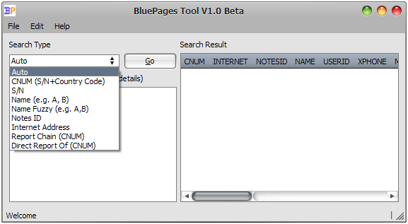
Figure 4.1 Choose Search Type

Fill in Search Entries
Fill in 1 or more search entries in Search For box.

Search Entries can be CNUM, S/N, Notes ID, Internet Address or Name. Or part of them. Except Direct Report Of, fuzzy match will be applied at the end of each search entry.

Tip – When using Auto Search Type, put a slash (/) after a Search For entry to make it more like a Notes ID, or it will probably be identified as a Name.

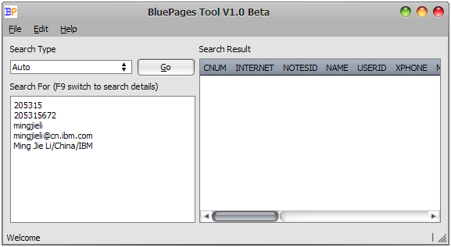
Figure 4.2 Fill in Search For

Go!
Press Go button, or use keyboard short [Ctrl][Enter] to start searching BluePages. Search duration depends on the number of search items and network bandwidth.

Figure 4.3 Go!

Search Detail
Press F9 to switch between Search Detail and normal view. Search Result is grouped by Search Entries, if 1 Search Entry has several results, they will be marked with the same color.

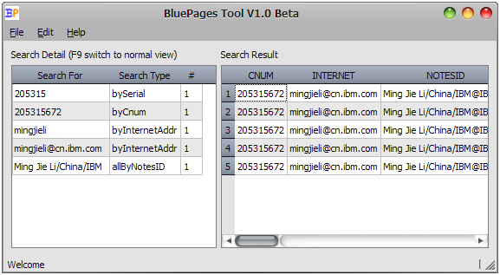
Figure 4.4 Search Details

Organize Columns
The Columns Dialog can be found in Edit menu, or directly press keyboard shortcut [Ctrl][O].

Columns in search result can be organized. You can choose to show/hide any columns, or change their order.

Press Save button to save settings (in settings.ini) and close dialog, search result will be refreshed immediately to reflect the changes.

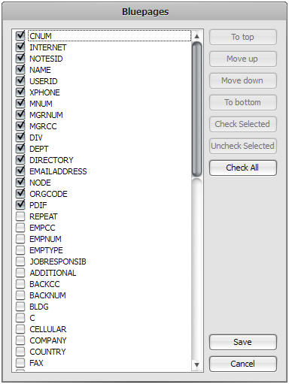
Figure 4.5 Organize Columns

Export
Search Result can be exported to files, supported file formats are CSV & Tab Delimited Values.

Only shown columns will be exported according to their order shown in Search Detail.

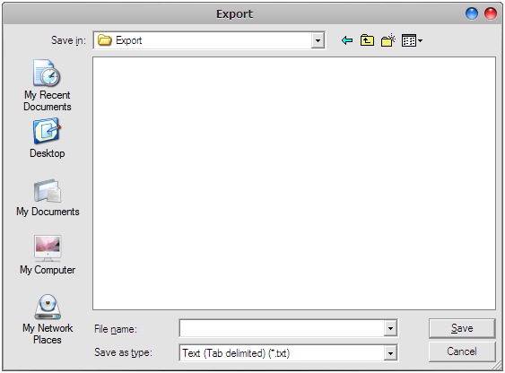
Figure 4.6 Export

Copy
Copy function is provided to quickly copy selected values into clipboard.

First select values in Search Result, then press [Ctrl][C] or select Copy from context menu.

Tip – To ensure data consistency, only continuous selection is supported

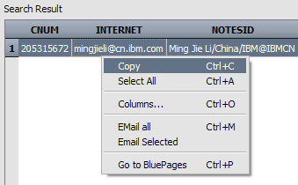
Figure 4.6 Copy

Email
To immediately contact all or several recipients. Email function is provided.

Use Email All to open default Email program, with all recipients in To list. Use Email Selected to Email selected recipients.

Tip – No matter which column(s) selected, Email address can be provided correctly.

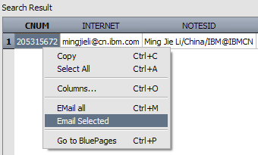
Figure 4.7 Email Selected recipient

Go to BluePages
Sometimes, we still want to check BluePages for further more information, like JRSS, photo, etc. which not listed.

Right click on 1 or more selected rows, choose Go to BluePages. Web page(s) will be opened in default browser.

Tip – Open too many web pages may cause workstation stop response. To prevent this, a warning will be prompted more than 10 pages selected to open.

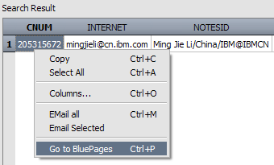
Figure 4.8 Go to BluePages

